DATA LOADING IN SNOWFLAKE
Types of Loading:
- Bulk loading
- Continuous loading
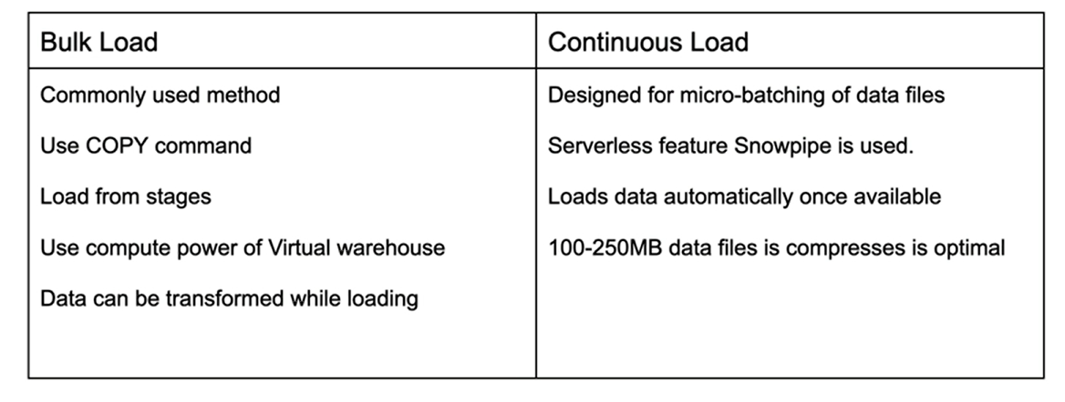
Let’s see it later in detail step by step

Stages:
Snowflake refers to the location of data files in cloud storage as a stage
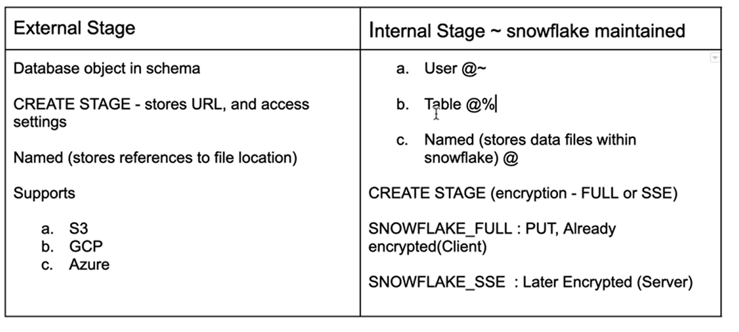
As these had to be understood by practical applications which we can see step by step later
SNOWSQL
It is required to install as while loading the data of files of size greater than 250 MB using snowflake UI can’t support and can’t maintain the history in the snowflake while loading. Hence we use SNOWSQL to prevent this

I request you to Please watch any YouTube video on how to install SNOWSQL as per your OS

Let’s see practical application in my snowsql

Creating a table using snowsql using my database and public schema, dropped table ‘first_table’ if exists any and creating a new table ‘first_table
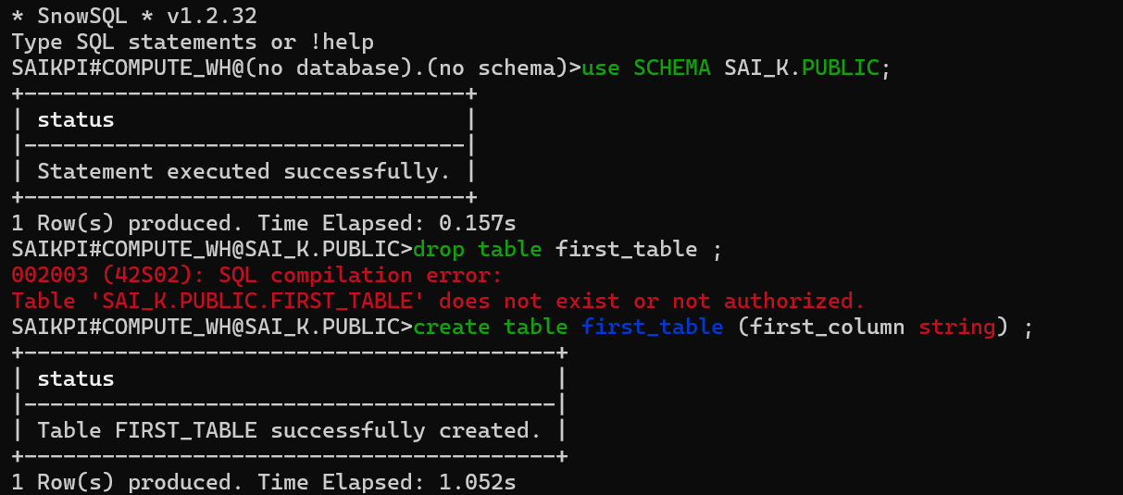
Let’s check in snowflake whether we got our table or not
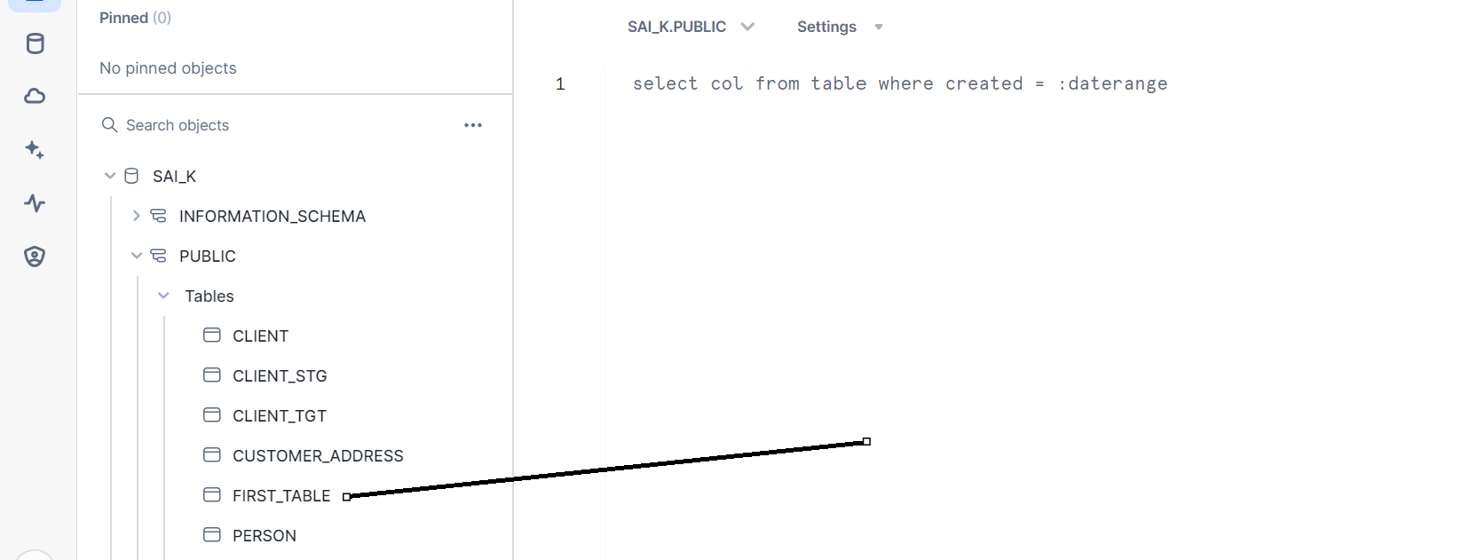
Inserting data
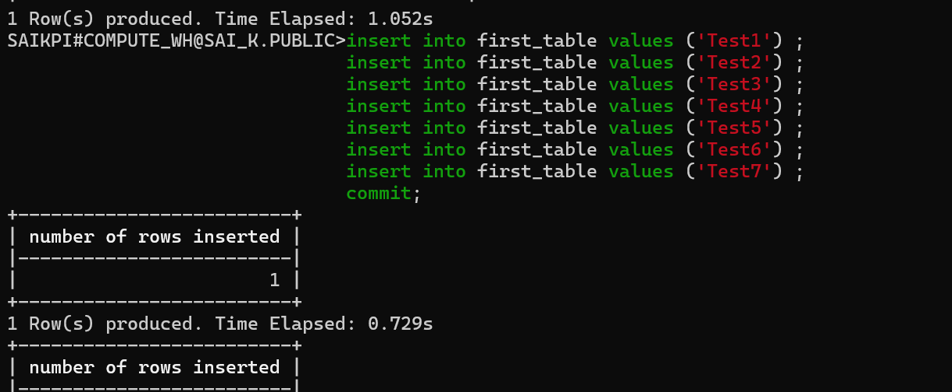
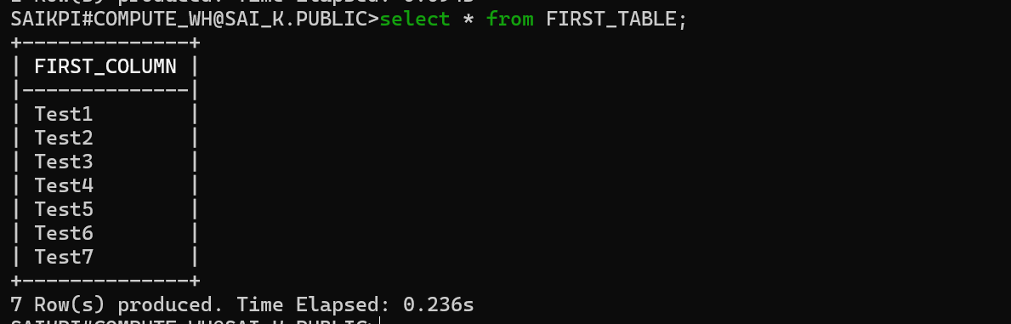
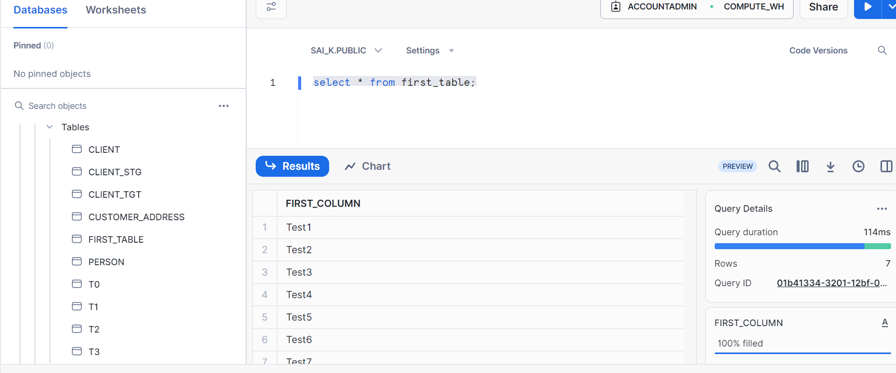

You can try your own operations and perform using snowsql. We will talk about stages, copy commands, file format objects in data loading etc. in later posts, Thanks

